Chapter 5 Implementation and Testing

Introduction
After the stages of the CRISP DM that deals with data preparation, making it ready for use in the model, comes the Implementation and testing stage. This stages in the CRISP DM are called the modelling and evaluation stages. This marked the start of the development of the model. Different models were built with plan to see which one works well and then they went through evaluation as a way of comparing.

Development environment
Django development was set for the development of this project. From all available wide range of Development environments Django fell to suitable for this project due to a number of advantages. These advantages affect the probably end user of the model and mainly the programmer.
The main reason behind the choice of Django was its capabilities to combine HTML codes with Python codes with easy. This advantage was mainly for the programmer since the programmer was much used to PHP programming. The imagination of how HTML is combined with PHP was the guide in development of this project. With that in hand Django made it easy through its internal instructions from pre-prepared files.
Django also has the build in codes that it comes with that are of much help when starting Python development for the first time. The files are a guide/ tutor on their own to anyone who is starting Django for the first time.
DJANGO has a private security key that insures security on the developed system. The code makes hacking of DJANGO programmed system harder to deal with (not impossible) with if you don’t know the password. The security key must be kept private to make the system secure after production.

Programming Languages
Python programming language was used for the programming of the system. Python is the code that was in charge of the whole model and the testing of the model. The reason for the choice was it capability to deal with relatively complex situations with easy. Python is also one of the programming languages that are easy to understand in terms of syntax as its syntax isn’t complicated that much.
In building the user interfaces HTML codes were used under DJANGO control as it was the development environment. HTML was chose as it produces high quality user interfaces.
The final product was then derived under DJANGO conditions with installation of some DJANGO plugins such as bootstrap and rest framework.

The Graphical User Interface (GUI)
The GUI was developed using the HTML language in DJANGO and the development was guided by the 10 heuristics for interface design defined by Jakob Nielsen. Cognitive dimensions of notations also came into play and influenced the design of the graphical user interface. There are a number of colors on the GUI. There is a notable different in colors on the side that general user see and what the system Admins can see. This was done so as to allow clear recognition when someone entered the Admin section.
The general view of everyone contains yellow as the main color and some white text on yellow bands and black where there is white as a back color. The general view home page is shown below.
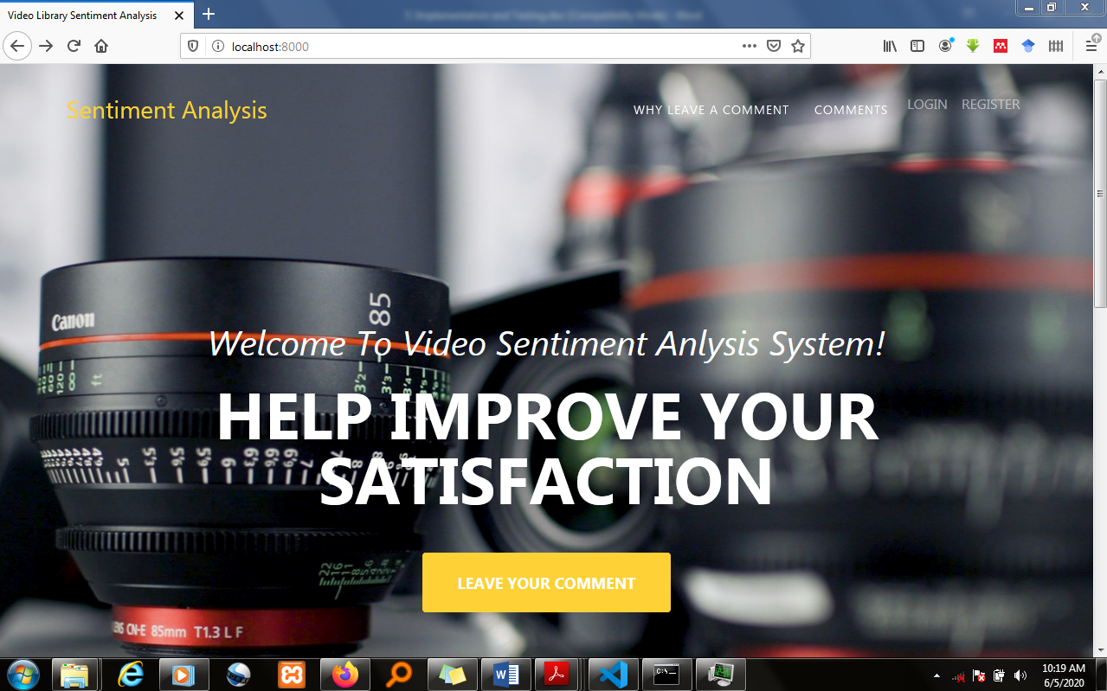

The below view is the view of the admin’s panel with different colors from the general view. This is where all the logical activities of the system are done by system admins.

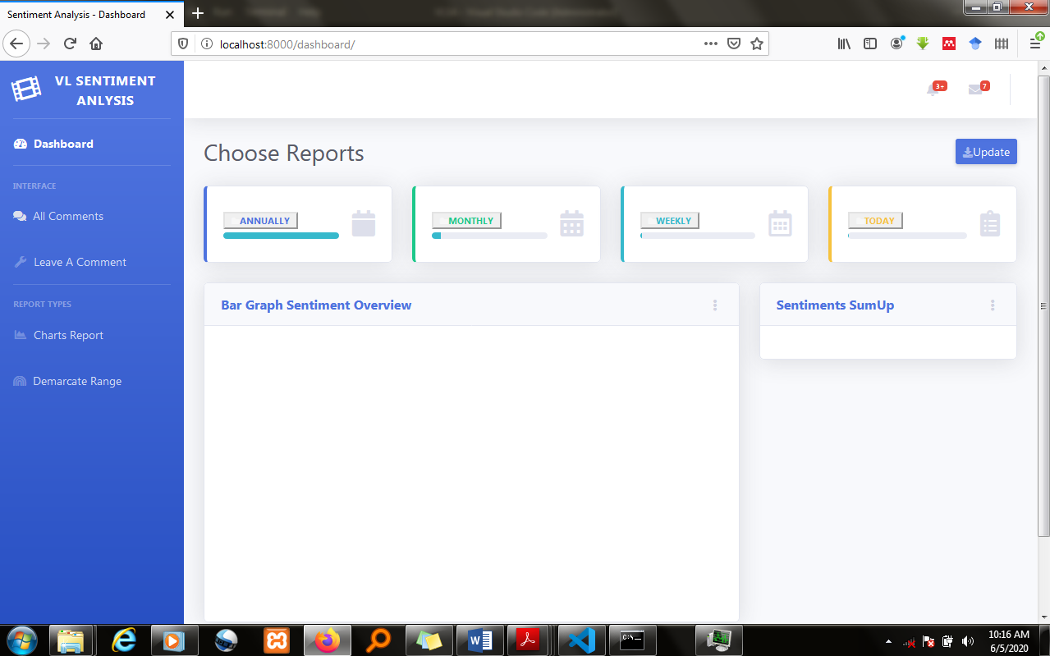

Testing
This stage of the CRISP DM (evaluation) software development methodology was done so as to see if the system met the objectives. Testing is an iterative process where each logical unit of code is tested. The process is done of different entities if the objective isn’t met then we pull back to understanding the objective and plan again how to tackle it. The testing of a conventional software system involves some of the following phases.
These are:
- Unit Testing
- Integrated Testing
- System Testing
Unit Testing:
A software module can be created by building up of many small parts into a single module. This small part is called as a unit. A unit is a piece of code that will perform a specific task. At the end of this testing all units will be tested so that we can get the correct result. By using unit testing we can easily identify the errors.
In this project a number of units where tested that include testing the model during development and also the user interfaces. While tackling this testing a number problems were met that were much of the model’s errors. The model was continually tested and changes to the code being done until the accuracy reached 88% as shown below. Changes that were done on the model that improved the accuracy was the change of the feature engineering tool from Hash Vectorizer to TF-IDF.
Integration Testing:
Combining all programs into a single application and testing its correctness is called as Integration testing. Even all programs work correctly they may give a false result when they work together. Integration is very important to get the completed result.
Integration testing was so troublesome, this was done to integrate the user interfaces and the model. The integration was aided by Django. A number of problems were met. These included a number of errors that are listed in the error log that I personal created for myself
.
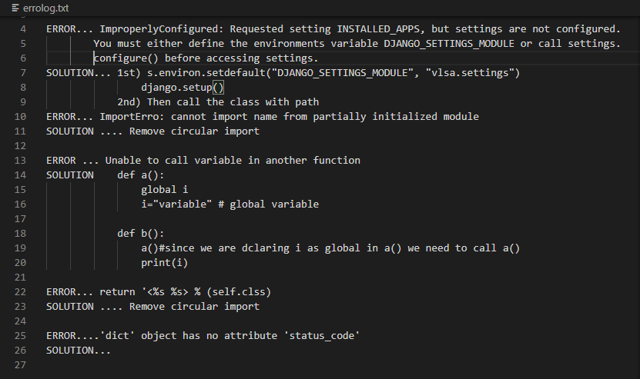
The errors where overcome with the interaction between the student and the supervisor as some were really new in the eyes of the student.
System Testing:
System testing means testing the whole system at once. By giving different inputs to the system we can check its correctness. For all inputs the system should produce correct result.
This was done to see the capabilities of the system as a whole after the units where combined. A number of tricky to recognize errors where seen that included login in with data from the wrong database. Error such as giving out an Annual report with the data for only two months. This stage was tricky and tiresome too and the errors were the most difficulty errors to discover. If conditions were perfect this was supposed to be done by an independent system tester.

Conclusion
An outline of the implementation of the system and how it was tested was conducted. The system’s functionality was tested against the requirements provided. The extent to which the system meets the objectives have been explicitly explained. The limitations of the system were expounded, as well as a clear walk through to the system operations.

